MYSQL Assignment 1 – DDL commands & Constrains
DDL Commands

- Table Creation (CREATE): Write the SQL statements to create a database named “employee” and the following tables based on the provided schema:
Departments
Location
Employees

- Database
create database employee;
`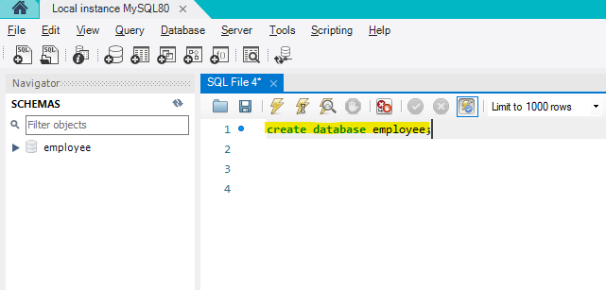
- Tables
Departments
create table Departments (
department_id INT,
department_name VARCHAR(100)
);
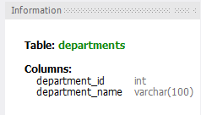

  - Location
create table Location (
location_id INT,
location VARCHAR(30)
);
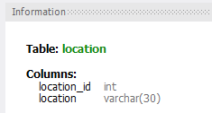

  - Employees
create table Employees (
employee_id INT,
employee_name VARCHAR(50),
gender ENUM('M','F'),
age INT,
hire_date DATE,
designation VARCHAR(100),
department_id INT,
location_id INT,
salary DECIMAL(10,2)
);
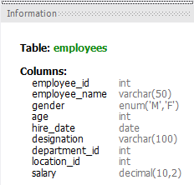

- Table Alteration (ALTER): Consider the following scenarios and write the SQL statements to alter the structure of the tables accordingly:

- Add a new column named "email" to the Employees table to store employee email addresses.
Alter table Employees
ADD email VARCHAR(100);

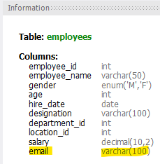

- Modify the data type of the "designation" column in the Employees table to support a wider range of values.

alter table employees
modify designation VARCHAR(255);

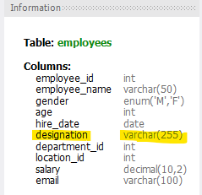

- Drop the “age” column from the Employees table.

alter table employees
drop age;

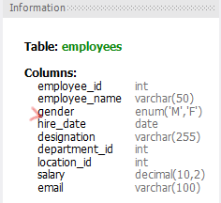
- Rename the “hire_date” column to “date_of_joining”.
alter table employees
rename column hire_date to date_of_joining;
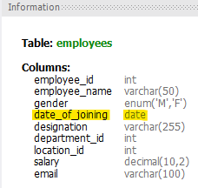

- Table Renaming (RENAME): Rewrite the SQL statements to rename the following tables:
- Rename the "Departments" table to "Departments_Info".
rename table departments to departments_Info;

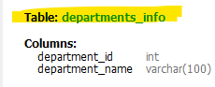

- Rename the "Location" table to "Locations".

rename table location to locations;

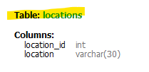

- Table Truncation (TRUNCATE): Write an SQL statement to truncate the Employees table.

truncate employees;
(It will erase the data of the table only not the table structure)

- Database & Table Dropping (DROP): Write the SQL statements to drop the Employees table and then the “employee” database.

drop table employees;

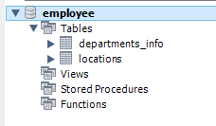

drop database employee;
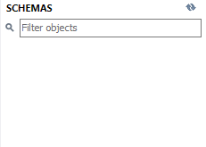

Constraints

- Database Recreation
Drop the 'employee' database if it exists and recreate it using the provided schema, ensuring that all tables are created with the appropriate constraints as instructed.
- Departments Table
- Ensure that the "department_id" uniquely identifies each department.
department_id INT Unique,

- Set up constraints on the "department_name" to avoid duplicate and null entries.
department_name VARCHAR(100) Unique NotNull
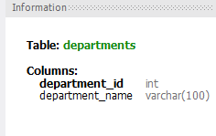

- Location Table
- Establish a mechanism to automatically generate unique identifiers for each location, ensuring that they are incremented sequentially.
CREATE TABLE Locations (
location_id INT AUTO_INCREMENT PRIMARY KEY,
);
- Implement constraints to prevent the insertion of null and duplicate locations.
location VARCHAR(30) Unique Not Null ;
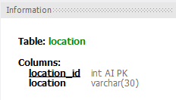

- Employees Table
- Guarantee that each employee has a distinct identifier.
- Create a restriction to ensure that the employee's name is always provided.
- Limit the acceptable values for the "gender" field to only 'M' or 'F'.
- Enforce a condition to ensure that the employee's age is 18 or above.
- Automatically assign the current date to the "hire_date" field if not specified.
- Establish links between the "department_id" and "location_id" fields in the "employees" table and their respective tables.

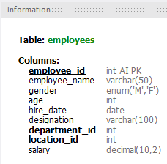
CREATE TABLE Employees (
employee_id INT AUTO_INCREMENT PRIMARY KEY,
employee_name VARCHAR(50) NOT NULL,
gender ENUM('M','F') NOT NULL,
age INT CHECK (age >= 18),
hire_date DATE DEFAULT (CURRENT_DATE),
designation VARCHAR(100),
department_id INT,
location_id INT,
salary DECIMAL(10,2),

FOREIGN KEY (department_id) REFERENCES
Departments(department_id),
FOREIGN KEY (location_id) REFERENCES Locations(location_id)
);

